

ADVIK HI-TECH PVT. LTD. Marketing- Corporate Strategy

## TABLE OF CONTENTS

|  |  |  |
| --- | --- | --- |
| **S.NO.** | **DESCRIPTION** | **Page Number** |
| 1. | Acknowledgement | 3 |
| 2. | Executive Summary | 4 |
| 3. | Organization Profile | 5 |
| 4. | Project Timeline | 6 |
| 5. | Market Sizing | 6-7 |
| 6. | Market Share | 7-8 |
| 7. | EV Traction motor for 2W Price Range | 8-9 |
| 8. | Future and Present technology | 9-10 |
| 9. | Target Customer | 11-14 |
| 10. | Voice of Customer | 14-15 |
| 11. | Retail Prices | 15-16 |
| 12. | Competitors | 16 |
| 13. | Technology Roadmap and Trends | 16-17 |
| 14. | Refrences | 17 |

## EXECUTIVE SUMMARY

In this Advik Hi-Tech Pvt. Ltd. project, I have completed two projects.

## PROJECT 1

**Title:** Go-to-Market Strategy for traction motors in 2-wheeler EV

**Objective:**

As a corporate strategy intern at an automobile component supplier, I am spearheading the development of a go-to-market strategy for the company’s entry into the two-wheeler EV

sector, focusing on battery components. Leveraging market research and strategy analysis, I aim to drive successful implementation and market penetration.

**Methods Used:**

|  |
| --- |
| **1)** Market sizing |
| **2)** Target customer |
| **3)** Voice of Customer |
| **4)** Price benchmarking |
| **5)** Technology changes and future requirements (Technology Roadmap) |
| **6)** Literature Survey and market research |

## ORGANIZATION PROFILE

**HISTORY**

Advik, a prominent manufacturer of precision components and systems for the automotive industry worldwide, was established in 2000. Their steadfast commitment to providing innovative, customized solutions to complex challenges in the industry has positioned them as a preferred partner for major vehicle manufacturers globally. With a workforce of over 4,000 qualified engineers and professionals spread across 10 manufacturing locations, Advik continues to expand its presence with manufacturing facilities, technical offices, sales offices, and partnerships in Asia, Europe, and America. Collaborating with their partners, Advik

plays a pivotal role in shaping the future of mobility.

## BACKGROUND

From its inception, Advik has focused on pushing the boundaries of technology and engineering excellence to meet the demands of the automotive sector. With a dedicated team of over 4,000 qualified engineers and professionals spread across 10 manufacturing locations,

Advik has consistently strived to stay ahead of the curve by investing in research and development and fostering a culture of innovation.

The company's journey began with supplying tensioners and oil pumps to the automotive industry. Over the years, Advik has diversified its product portfolio and expanded its

presence to cater to a wide range of customers, including global two-wheeler OEMs. In 2015, Advik ventured into the four-wheeler segment, followed by a foray into electric vehicles in 2020, reflecting its commitment to staying at the forefront of technological advancements in

the automotive space.

## MARKET PRESENCE

Advik's market presence extends globally, with a robust presence in Asia, Europe, and

America. Forming strategic alliances and partnerships, the company has become a trusted partner to major vehicle manufacturers worldwide. Equipped with cutting-edge manufacturing facilities, Advik ensures adherence to global standards in quality and

functionality. Central to its operations is the Global Research & Design lab in Pune, India, driving innovation in mobility solutions through collaborative efforts with internal and external stakeholders, resulting in numerous patented breakthroughs.

Furthermore, Advik prioritizes operational excellence, leveraging its engineering expertise to streamline processes and expedite product delivery. Initiatives like the Operational

Excellence Model and Vendor Excellence Program (DISHA) underscore its commitment to enhancing efficiency, quality, and sustainability throughout the supply chain. Complementing its business focus, Advik remains dedicated to sustainability and social responsibility,

implementing eco-friendly manufacturing practices and engaging in community development initiatives to create enduring value for stakeholders while fostering economic, social, and environmental benefits.

**Project Timeline:**

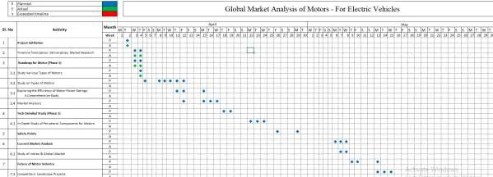

**Market Sizing**

Approaches used for Market sizing techniques for electric vehicle (EV) motors in the two-wheeler segment:

1. **Top-Down Approach**: This method involves estimating the total addressable market (TAM) by extrapolating from macro-level data and industry reports. For example, you might start with the total number of two-wheelers sold globally and then estimate the percentage of them that will transition to electric in the coming years based on industry trends, government policies, and consumer preferences.
2. **Bottom-Up Approach**: In this approach, you estimate the market size by aggregating the sales of EV motors from individual manufacturers or suppliers. This requires gathering data from various sources such as EV motor manufacturers, distributors, and industry reports to get a granular understanding of the market.
3. **Segmentation**: Segmenting the market based on various factors such as geographical regions, types of two-wheelers (e.g., scooters, motorcycles), price ranges, and consumer demographics allows for a more detailed analysis. Each segment may have its own growth rate and adoption trends, which can be analyzed separately.
4. **Survey and Interviews**: Conducting surveys and interviews with stakeholders such as EV manufacturers, consumers, dealers, and industry experts can provide valuable

insights into market demand, preferences, and purchasing behavior. These qualitative data can complement quantitative analysis and help validate assumptions.

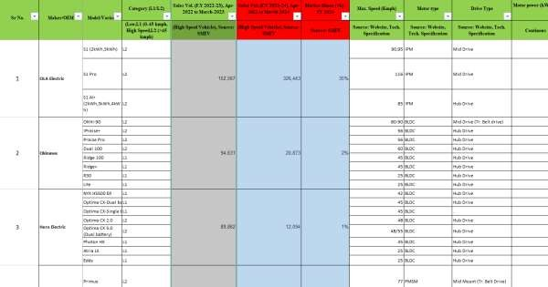

|  |  |  |
| --- | --- | --- |
|  | **Market Share** |  |

1. **Online Surveys and Literature Review**: Conducted research through reputable sources such as SMEV website and EV Ready, along with literature surveys, to gather data on market share trends of EV traction motors specifically for two-wheelers.
2. **Field Visits to EV Showrooms**: Visited multiple EV showrooms specializing in two- wheelers to gain firsthand insights into the types of motors being used and their respective prices.
3. **Market Share Calculation**: Utilized the gathered data to calculate market share by multiplying the cost of motors for various individual two-wheeler models by the number of units sold by each company.
4. **Validation and Accuracy**: Ensured the accuracy and reliability of the calculated market shares by cross-referencing information from different sources and verifying with industry experts if needed.
5. **Comprehensive Analysis**: Integrated findings from online surveys, literature reviews, showroom visits, and market share calculations to develop a comprehensive understanding of the EV traction motor market for two-wheelers.

|  |  |  |
| --- | --- | --- |
| 6. | **Data-driven Decision Making** | : Used the gathered insights to inform decision- |
| making processes related to market positioning, product development, and strategic planning within the EV industry. | | |

By following this structured approach, a thorough understanding of the market dynamics and trends surrounding EV traction motors for two-wheelers was achieved, facilitating informed decision-making and strategy formulation.

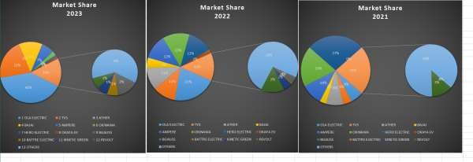

**EV Traction motor for 2W Price Range**

1. **Observations from EV Company Visits**: During visits to various EV two-wheeler manufacturers, it became evident that each company sources motors from different Original Equipment Manufacturers (OEMs).
2. **Price Range Determination**: After gaining insights into the pricing structure, it was observed that the cost of the motor typically falls within a range of 8% to 12% of the total vehicle cost for EV two-wheelers.
3. **Establishing OEM Price Range**: This range represents the pricing directly from the OEMs and not the retail price offered to customers.
4. **Understanding Minimum and Maximum Price Points**: By extrapolating this percentage range onto the overall vehicle cost, a rough estimate of the minimum and maximum price points for the motor when purchased from an OEM was derived.
5. **Clarity on Pricing Dynamics**: This analysis provided clarity on the pricing dynamics between OEMs and EV two-wheeler manufacturers, guiding decisions related to sourcing strategies and cost management within the industry.

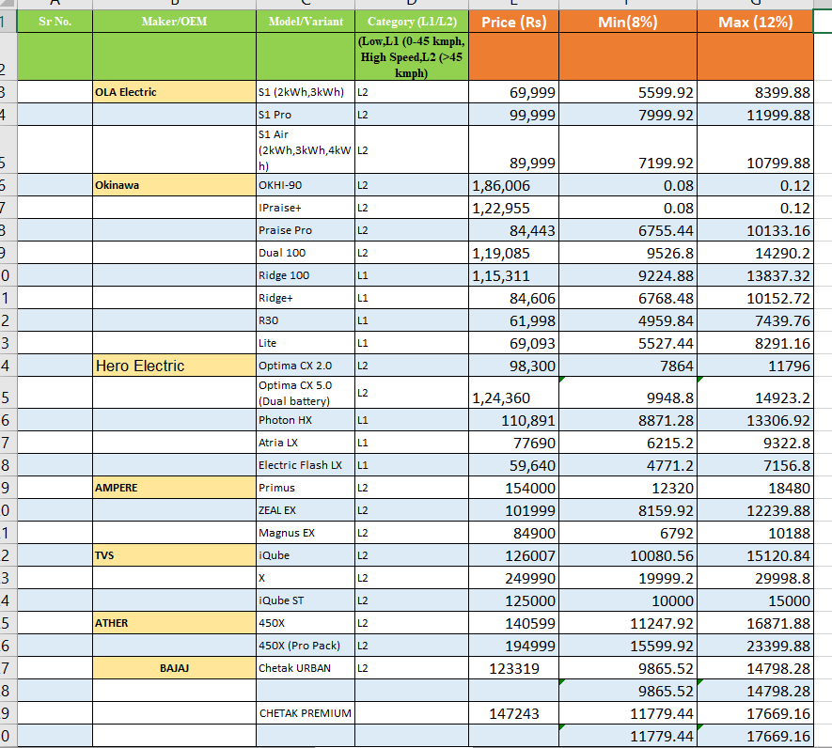

**Present and Future Technology on EV Traction motors for 2 wheeler EV:**

1. **Extensive Literature Review**: Conducted thorough research by examining EV magazines, news articles, and various online sources to gather insights into the current and future technology trends of EV traction motors.
2. **Exploration of EV Stores and Manufacturing Units**: Visited EV vehicle stores and manufacturing facilities to observe firsthand the technology being implemented in EV traction motors and understand the current industry standards.
3. **Engagement with Service Centers**: Interacted with EV service centers to gather feedback on the performance and durability of existing EV traction motors, identifying areas for improvement and innovation.
4. **Insight into Present Technology**: Through this comprehensive approach, gained a clear understanding of the current state of EV traction motor technology, including its capabilities, limitations, and emerging trends.
5. **Anticipation of Future Needs**: Leveraged the insights gathered to anticipate future market demands and technological advancements in EV traction motors, ensuring readiness to meet evolving consumer preferences and industry standards.
6. **Strategic Planning**: Armed with knowledge of both present capabilities and future trends, used this information to inform strategic planning processes, such as product development roadmaps and investment decisions, to stay competitive in the dynamic EV market.

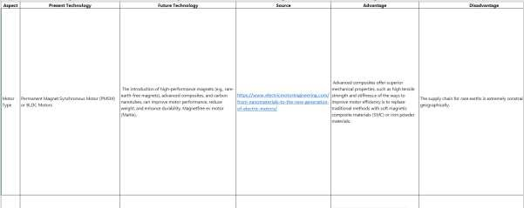

**Target Customer**

After conducting an extensive market survey across various companies, I focused on understanding the traction motor purchasing patterns within the 2-wheeler EV industry. By analyzing data from sources like SMEV's website, which provided sales insights for each 2- wheeler EV company, I was able to delineate the primary, secondary, and tertiary customer segments for Advik. The primary customer segment comprises those directly procuring products from Advik, indicating a higher likelihood of sales turnover. Hence, companies like Ampere, BGAUSS, HERO ELECTRIC, and OKAYA EV emerged as primary customers due to their substantial sales figures and brand prominence.

In the secondary customer category, I placed BATTRE ELECTRIC, KINETIC GREEN, and REVOLT, considering their significant market presence and potential for future expansion. Lastly, for the tertiary customer segment, which includes companies like TVS, OLA ELECTRIC, OKINAWA, BAJAJ, and ATHER, I recognized their relevance but anticipated comparatively lower sales ratios owing to factors such as established brand loyalty and diverse product portfolios. This segmentation strategy aims to strategically align Advik's offerings with the distinct needs and potential of each customer segment within the evolving landscape of the 2-wheeler EV market.

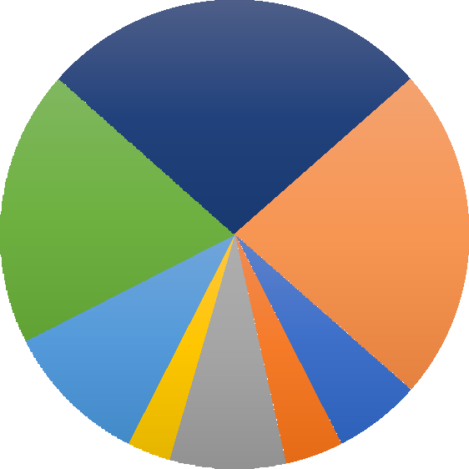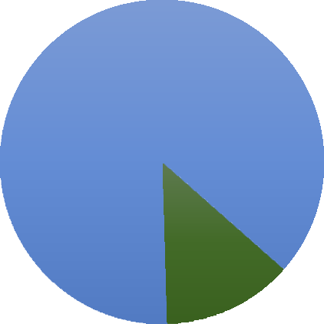

**Market Share**

**2021**

27%

0%

20%

19%

23%

0%

10%

6%

3%

3% 8% 4%

OLA ELECTRIC

OKINAWA

TVS ATHER

HERO ELECTRIC OKAYA EV

BAJAJ

BGAUSS

AMPERE

BATTRE ELECTRIC

KINETIC GREEN REVOLT OTHERS

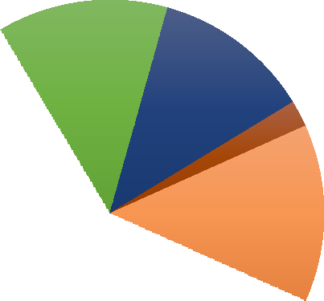

**Market Share**

**2022**

13%

12%

12%

10%

2%

5%

13%

11%

0%

1%

0%

11%

21%

2%

OLA ELECTRIC

TVS

ATHER

BAJAJ

AMPERE

OKINAWA HERO ELECTRIC OKAYA EV BGAUSS BATTRE ELECTRIC

KINETIC GREEN REVOLT OTHERS

|  |  |  |  |  |
| --- | --- | --- | --- | --- |
| 1 OLA ELECTRIC | 2 TVS | 3 ATHER | 4 BAJAJ | 5 AMPERE |
| 6 OKINAWA | 7 HERO ELECTRIC | 8 OKAYA EV | 9 BGAUSS | 10 BATTRE ELECTRIC |
| 11 KINETIC GREEN | 12 REVOLT | 13 OTHERS |  |  |

**Primary Target Customer (Sales Volume) (Sales Volume):**

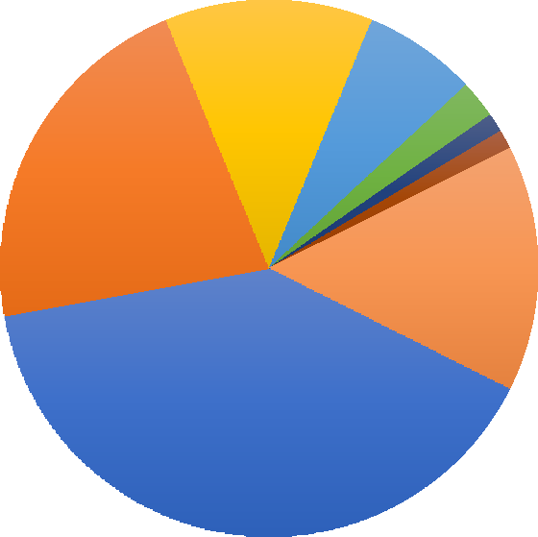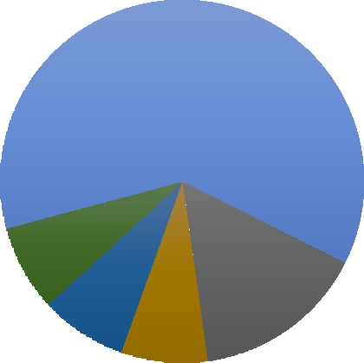

**Market Share**

**2023**

0% 13%

7%

2%

9%

22%

11%%

14%

1%

1%

2%

1%

40%

|  |  |  |  |  |  |
| --- | --- | --- | --- | --- | --- |
| **Row Labels** | **Sum of 2022** | **Sum of 2023** | **Sum of 2024** | **Sum of 2025** | **Sum of 2026** |
| AMPERE | 25516 | 87392 | 55057 | 79832.65 | 115757.3425 |
| BGAUSS | 0 | 4147 | 15235 | 22090.75 | 32031.5875 |
| HERO ELECTRIC | 69235 | 89874 | 12094 | 17536.3 | 25427.635 |
| OKAYA EV | 0 | 13175 | 14035 | 20350.75 | 29508.5875 |
| **Grand Total** | **94751** | **194588** | **96421** | **139810.45** | **202725.1525** |

**Secondary Target Customer:**

|  |  |  |  |  |  |
| --- | --- | --- | --- | --- | --- |
| **Row Labels** | **Sum of 2022** | **Sum of 2023** | **Sum of 2024** | **Sum of 2025** | **Sum of 2026** |
| BATTRE ELECTRIC | 0 | 896 | 4901 | 7106.45 | 10304.3525 |
| KINETIC GREEN | 0 | 5572 | 9703 | 14069.35 | 20400.5575 |
| OTHERS | 51083 | 73495 | 79622 | 115451.9 | 167405.255 |
| REVOLT | 7641 | 12932 | 7342 | 10645.9 | 15436.555 |
| **Grand Total** | **58724** | **92895** | **101568** | **147273.6** | **213546.72** |

**Tertiary Target Customer(Sales Volume):**

|  |  |  |  |  |  |
| --- | --- | --- | --- | --- | --- |
| **Row Labels** | **Sum of 2022** | **Sum of 2023** | **Sum of 2024** | **Sum of 2025** | **Sum of 2026** |
| TVS | 9740 | 82109 | 182959 | 265290.55 | 384671.2975 |
| OLA ELECTRIC | 14405 | 152779 | 326443 | 473342.35 | 686346.4075 |
| OKINAWA | 47926 | 95939 | 20873 | 30265.85 | 43885.4825 |
| BAJAJ | 7114 | 32805 | 106990 | 155135.5 | 224946.475 |
| ATHER | 19981 | 76939 | 108872 | 157864.4 | 228903.38 |
| **Grand Total** | **99166** | **440571** | **746137** | **1081898.65** | **1568753.043** |

# Voice of Customer

To capture the voice of the customer regarding traction motors in the 2-wheeler EV segment, I extensively engaged with servicing centers and mechanics to understand the primary concerns customers raise. By visiting numerous service centers across various 2-wheeler EV companies, I gathered insights into the major issues customers typically encounter with their motors. Conversations with mechanics provided valuable feedback on common complaints and challenges, enabling us to identify areas for improvement.

Additionally, I conducted meetings with OEMs in China to gain a broader perspective on customer concerns. These discussions allowed us to explore common issues faced by customers across different markets and identify trends or patterns in motor-related complaints. By leveraging insights from both local service centers and international OEMs, we aimed to develop a comprehensive understanding of customer needs and pain points.

This proactive approach to gathering customer feedback ensures that we are equipped to address prevalent issues effectively, enhancing the reliability and performance of traction motors in the 2-wheeler EV segment.

**Heat Dissipation:**

Due to the compact size and high power density of two-wheeler traction motors, heat dissipation becomes a critical issue. Overheating can occur more quickly in these motors, leading to performance degradation and potential damage.

**Acceleration & Torque:**

Two-wheeler EVs require quick acceleration and responsive torque delivery. Traction motors must be designed to provide sufficient torque at

low speeds while also delivering high-speed performance.

**Regenerative Braking Efficiency:** Energy losses in regen braking system.

**Supply chain in traction motors**

Scarcity of rare earth-free magnets or permanent magnets for which there is a huge dependency on China.

**Quality issues**

Traction motors can overheat due to prolonged usage or inefficient cooling systems. This can lead to performance degradation and potentially even motor failure if not addressed promptly.

**Power to weight ratio issue with current motors**

Using lightweight yet durable materials in motor construction, such as high-strength alloys or carbon fiber composites, can help reduce weight without sacrificing performance or reliability.

# RETAIL PRICING

After conducting a comprehensive market survey, I discerned that mid-drive EV traction motors were priced around 12,000 INR, whereas hub-drive EV traction motors were priced at approximately 8,000 INR. Delving deeper, I meticulously analyzed the sales data for each type of motor across various models of 2-wheeler EVs, allowing me to gauge both the volume and revenue of each segment.

Upon scrutinizing the trends, a clear pattern emerged: the sales and revenue of mid-drive motors showed a consistent upward trajectory year on year, whereas those of hub-drive motors exhibited a declining trend over the same period. This analysis led me to a compelling conclusion: Advik Hi-Tech should pivot towards manufacturing mid-drive motors in line with the prevailing market dynamics.

This strategic decision is underpinned by the significant growth potential offered by the mid- drive motor segment, as evidenced by its increasing sales and revenue figures. By aligning our manufacturing focus with the burgeoning demand for mid-drive motors, Advik Hi-Tech stands poised to capitalize on market opportunities and solidify its position as a leading provider of traction motors for 2-wheeler EVs.

Furthermore, this shift in manufacturing strategy not only reflects a proactive response to market trends but also underscores our commitment to delivering innovative solutions that

meet evolving customer needs. Through agile adaptation and strategic foresight, Advik Hi- Tech aims to carve a niche in the competitive landscape of the 2-wheeler EV traction motor market, driving sustainable growth and fostering long-term success.

# COMPETITORS

To comprehensively understand the competitive landscape in the traction motor market for 2- wheeler EVs, extensive market research was imperative. This involved a multifaceted approach, including on-the-ground investigations at exclusive showrooms and service centers, as well as online exploration on platforms like Made in China and IndiaMART.

Through meticulous scrutiny, I identified both major and minor players in the industry, delving into details such as the types of motors they manufacture, their respective revenues, sales figures, and customer base. This in-depth analysis provided valuable insights into the strengths, weaknesses, opportunities, and threats posed by each competitor.

By examining the OEMs catering to the 2-wheeler EV traction motor market, I gained a nuanced understanding of their market positioning, product offerings, and customer relationships. This holistic view enabled me to discern emerging trends, competitive dynamics, and areas of potential collaboration or differentiation.

Armed with this knowledge, businesses can make informed decisions regarding product development, marketing strategies, and partnerships to gain a competitive edge in the rapidly evolving landscape of 2-wheeler EV traction motors.

# Technology Roadmap

**Past:**

Ányos Jedlik built the first rudimentary but working d.c. electrical machine, the first electric motor in the world

**Present:**

* Permanent Magnet Synchronous Motor (PMSM) or BLDC Motors
* Moderate power and torque output
* Compact size with moderate weight
* Air or liquid cooling systems

**Future:**

* Rare-earth-free magnets, advanced composites, and carbon nanotubes.
* Higher power and torque output for improved performance by using neodymium magnets
* Smaller and lighter motors without compromising performance.
* Increasing the surface area of the fins in the motor. Fiber-reinforced polymer materials will help motor designers to achieve the function of cooling the motor

# Refrences

1. <https://www.smev.in/>
2. [https://evmagazine.com/top10/top-10-technologies-driving-the-shift-to-electric-](https://evmagazine.com/top10/top-10-technologies-driving-the-shift-to-electric-vehicles) [vehicles](https://evmagazine.com/top10/top-10-technologies-driving-the-shift-to-electric-vehicles)
3. <https://evreporter.com/ev-powertrain-components-manufacturers-in-india/>
4. [https://hp-power.en.made-in-china.com/product-group/gohAOqsBfuWm/PMSM-](https://hp-power.en.made-in-china.com/product-group/gohAOqsBfuWm/PMSM-1.html) [1.html](https://hp-power.en.made-in-china.com/product-group/gohAOqsBfuWm/PMSM-1.html)
5. <https://dir.indiamart.com/impcat/electric-vehicle-motors.html>
6. <https://www.acko.com/traffic-rules/motor-vehicles-act/>